Answers
1. (a) Explain the purpose of the CPU. [1]
To execute / run programs (1), to coordinate and manage the hardware resources (1).
(b) Here are some statements about the CPU of a computer.
Tick one box in each row to show whether the statement is true or false. [4]
Statement | True | False
CPU stands for Central Programming Unit
The CPU carries out arithmetic and logical instructions
Registers are a type of super-fast memory in the CPU
The Von Neumann architecture only holds data in memory

(c) The CPU features a number of registers. Complete the table and describe the purpose of each register [4]
Register | Purpose
Memory Address Register | The MAR holds the address of the current instruction being executed and the address of the data that needs to be accessed.
Memory Data Register | The MDR holds first the instruction, and then the data (if any) to be used in the instruction, copied from RAM.
Current Instruction Register | The CIR holds the instruction that is currently being decoded and executed.
Program Counter | The Program Counter holds the address of the next instruction to be executed.
Accumulator | The accumulator is where arithmetic and logic results are temporarily stored.

2. The CPU operates on a cycle.
(a) What is the name of this cycle? [1]
Fetch-decode-execute cycle.

(b) Explain the different stages of the cycle.
You may draw a diagram to help with your explanation. [5]
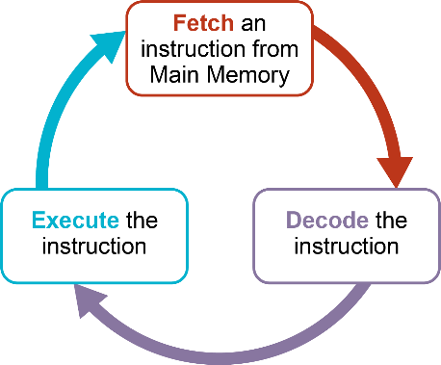
1 mark for showing fetch/decode/execute in a cycle.
1 mark for mentioning instruction in each part (e.g. fetch the instruction)
Fetch: The Program Counter (PC) in the CPU specifies where the next instruction to be executed is stored. (1) The CPU fetches the next instruction to be executed from memory. (1) The instruction is transferred to the MDR (1). The address of the instruction being fetched is placed in the MAR (1). The current instruction register (CIR) holds the instruction that is currently being decoded/executed (1).
Decode: It decodes the instruction (1).
Execute: The processor carries out/runs/executes the instruction. (1) The Program Counter is updated/incremented to point to the next instruction. (1)
The process is repeated. (1)
Any 4 points from above.
[Total 15 marks]

